Project Design Phase-II
Technology Stack (Architecture & Stack)

Date | 8 Feb 2026
Team ID | LTVIP2026TMIDS83762
Project Name | LearnHub: Your Center for Skill Enhancement
Maximum Marks | 4 Marks

Technical Architecture:
LearnHub is built on a modular MERN stack architecture designed to provide secure, scalable, and structured online learning. The system follows a layered architecture model where the React frontend handles user interaction, the Node.js & Express backend manages business logic and API routing, and MongoDB serves as the centralized data storage layer.
User requests flow from the frontend through REST APIs to the backend, where authentication is verified using JWT middleware. The backend processes course management, payment verification, progress tracking, and certificate generation before interacting with the MongoDB database. Video files are handled using Multer and stored locally (or cloud-ready for future enhancement). PDFKit dynamically generates certificates once course completion criteria are satisfied.
This layered and modular design ensures security, scalability, maintainability, and smooth interaction between Admin, Teacher, and Student users.
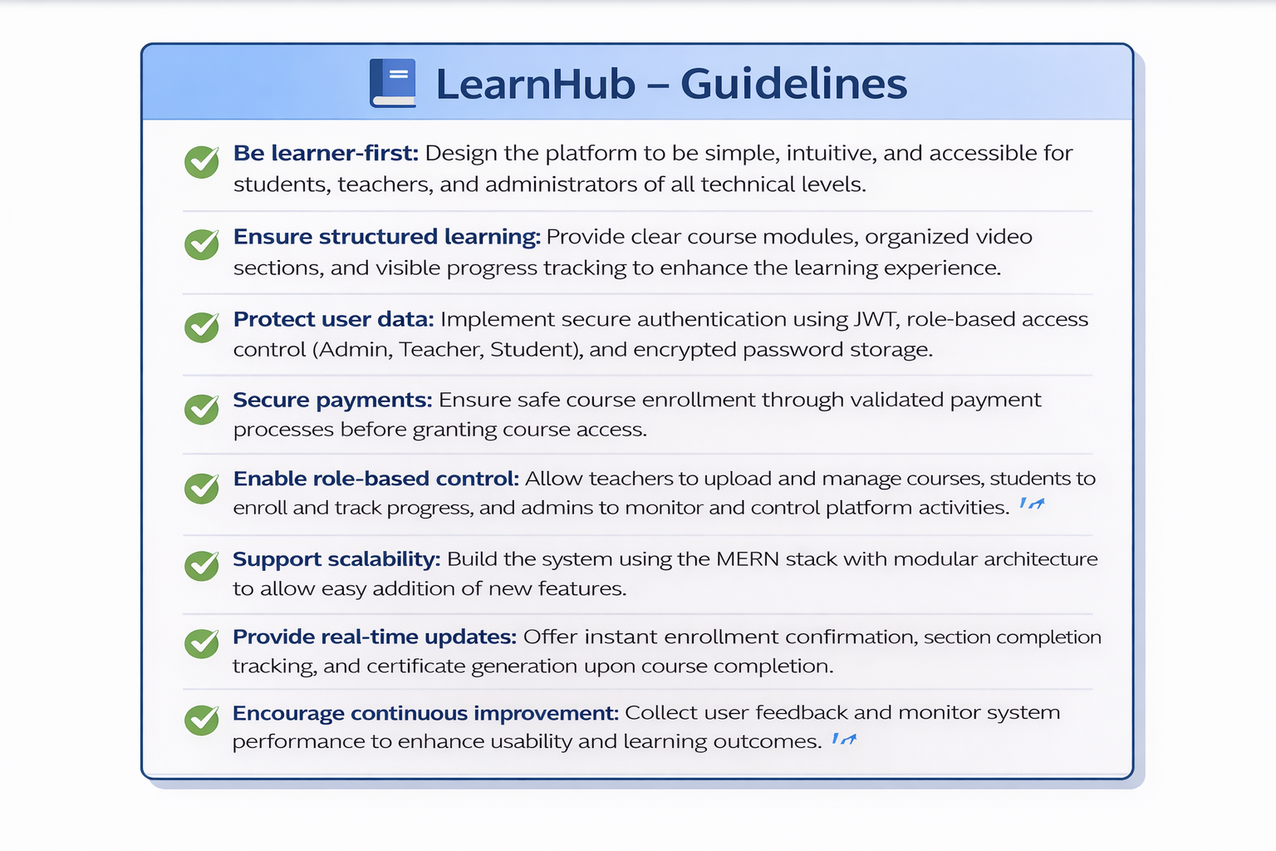
Guidelines:
Be citizen-first: Make it inclusivemultilingual, and easy to use.
Think green: Align with sustainability goals like clean energy and smart mobility.
Protect data: Ensure privacy, transparency, and ethical AI.
Stay flexible: Use modur, scalable, and open-source tech.
Act in real time: Use IoT and AI for instant insights and alerts.
Listen and adapt: Collect feedback and keep improving

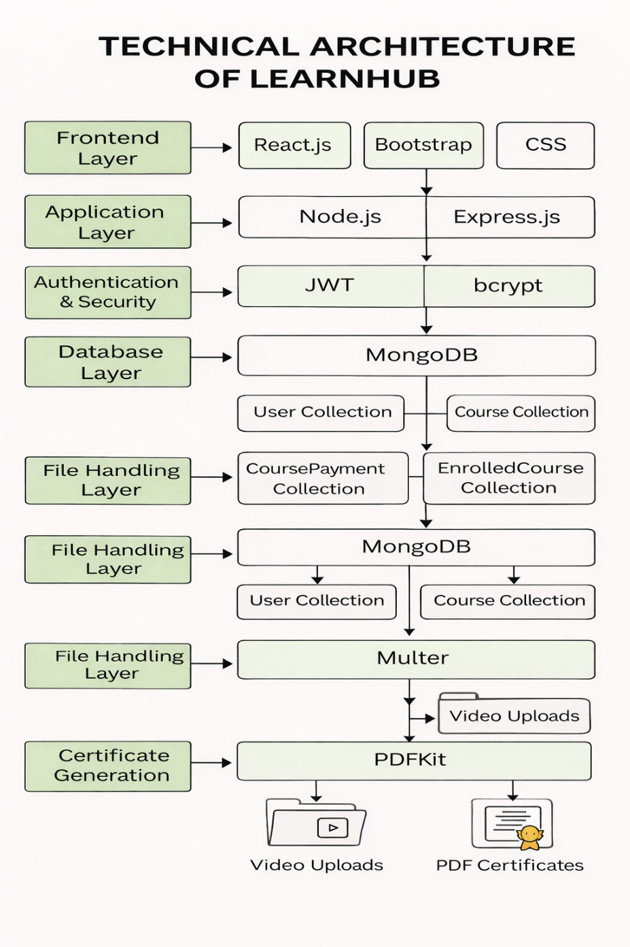

Table-1 : Components & Technologies:
S.No | Component | Description | Technology
 | User Interface | Web-based interactive dashboards for Admin, Teacher,  and Student | React.js, HTML, CSS, Bootstrap
 | Backend Server | Handles routing, authentication, business logic, and API management | Node.js, Express.js
 | Database | Stores users, courses, enrollments, and payment records | MongoDB (Mongoose ORM)
 | Authentication System | Secure login and session management | JWT (JSON Web Token), bcrypt
 | File Upload System | Upload and manage course videos | Multer
 | Payment Module | Simulated payment validation before enrollment | Custom Express API
 | Certificate Generator | Generates downloadable PDF certificates | PDFKit
 | API Communication | Handles frontend-backend communication | RESTful APIs, Axios
 | Role-Based Access Control | Restricts access based on user type (Admin, Teacher, Student) | Middleware (RBAC)
 | Development Environment | Local development and testing | Node.js runtime, npm
 | Infrastructure (Server / Cloud) | Deployment on local server or cloud platforms | AWS / Azure / Render / Docker (Future Ready)

Table-2: Application Characteristics:
S.No | Characteristics | Description | Technology
 | Open-Source Frameworks | Built entirely using open-source technologies | MERN Stack
 | Security Implementations | Password hashing and token-based authentication | Role-Based Access Control
 | Scalable Architecture | Modular backend and component-based frontend | bcrypt, JWT
 | Availability | Can be deployed on cloud with 24/7 availability | express + React Architecture
 | Performance | Optimized database queries and efficient API responses | MongoDB Indexing, Async APIs
 | Maintainability | Clean folder structure and separation of concerns | MVC-like Structure
 | Data Integrity | Schema validation and relationship mapping | Mongoose Schema Validation
 | Future Expandability | Future Expandability | Modular API Design

